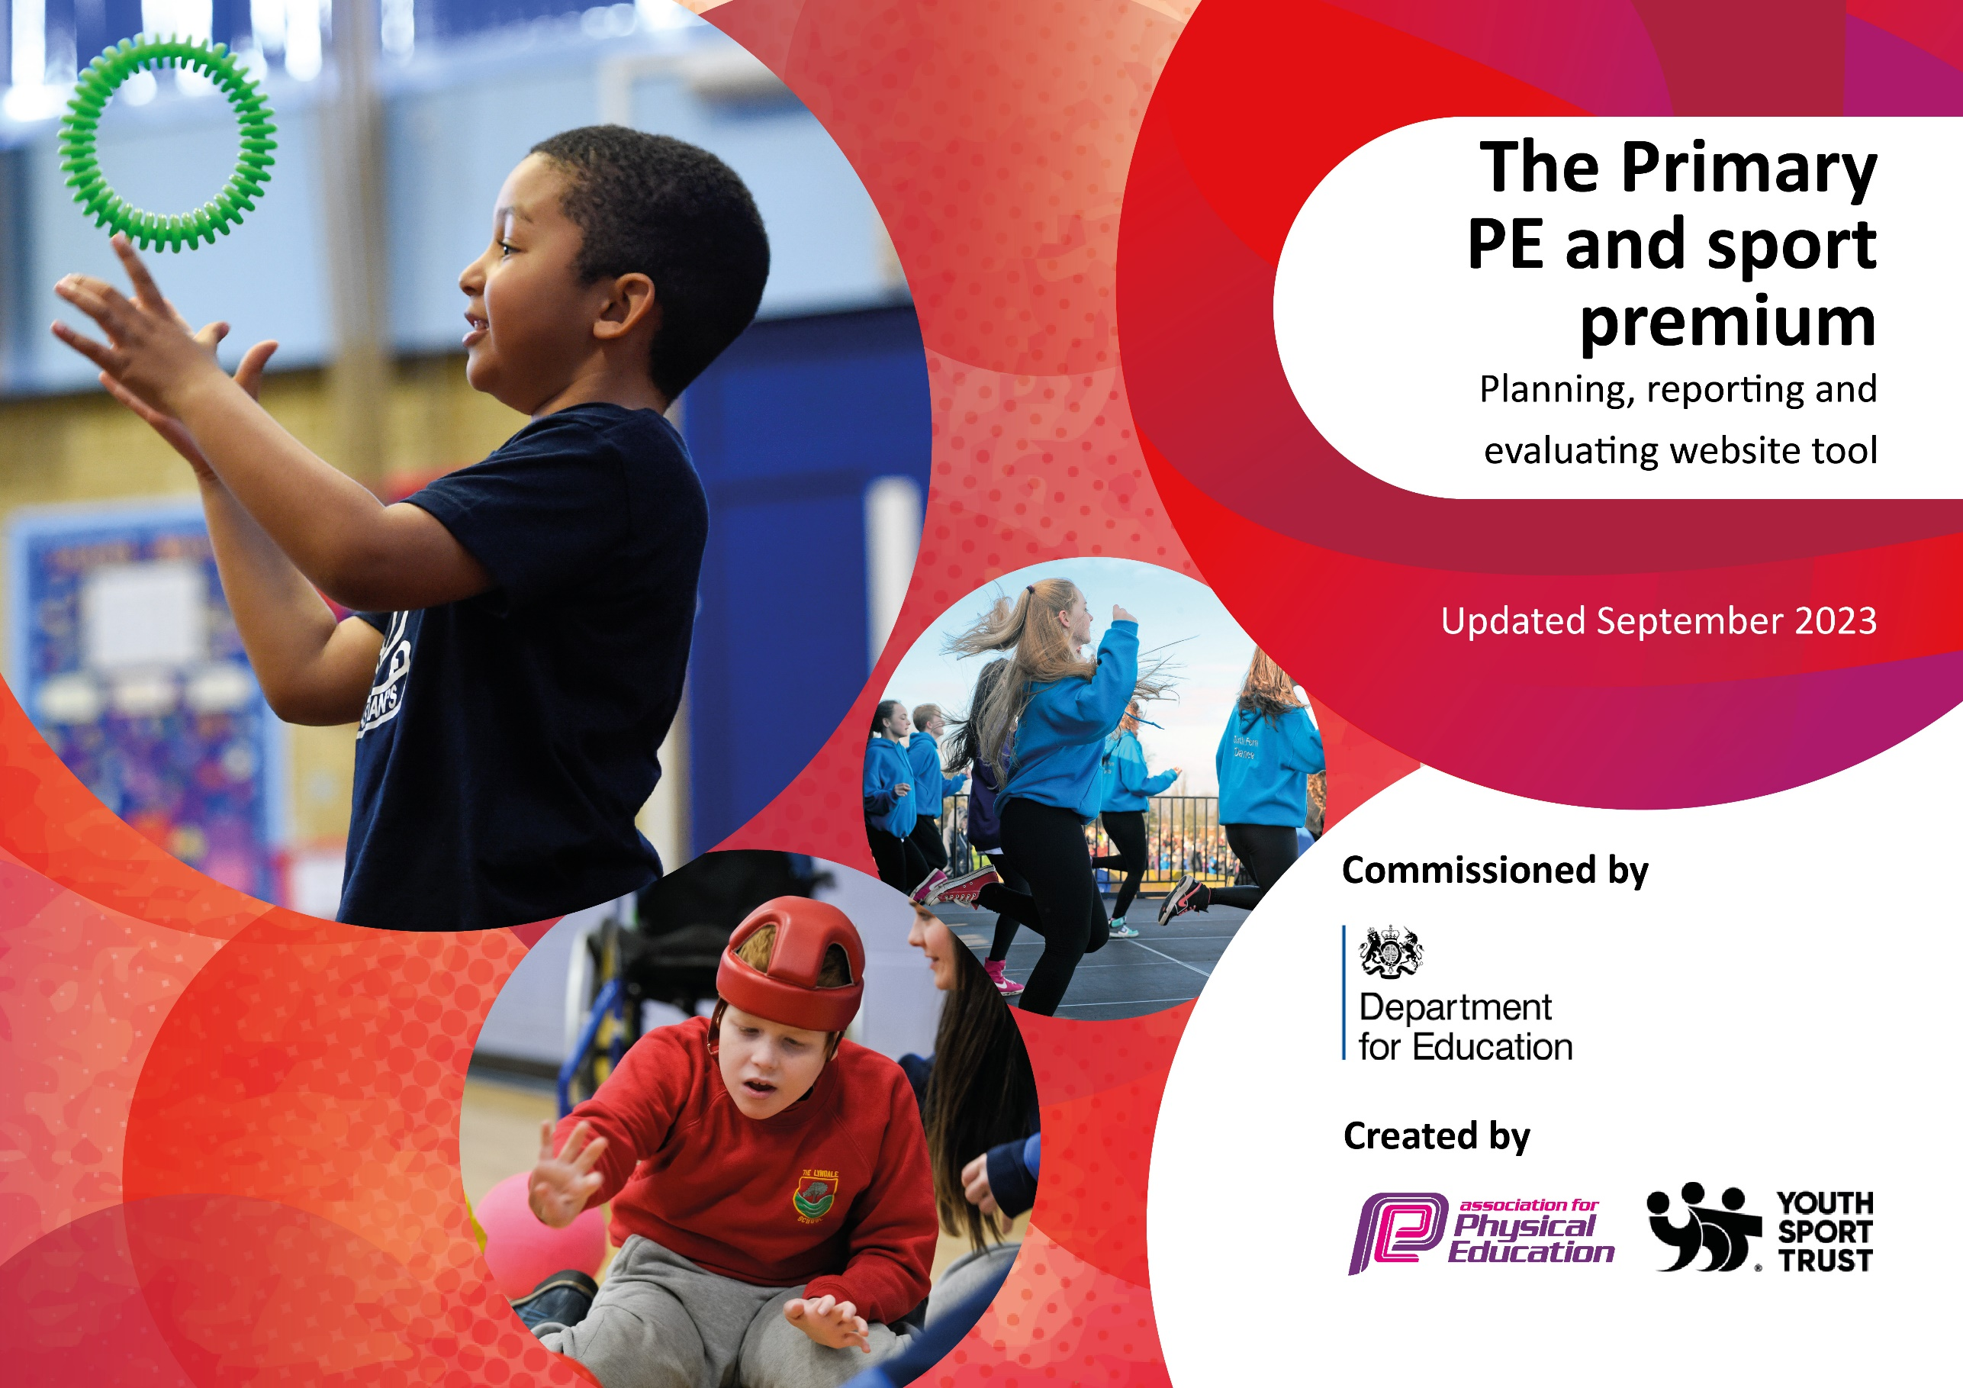

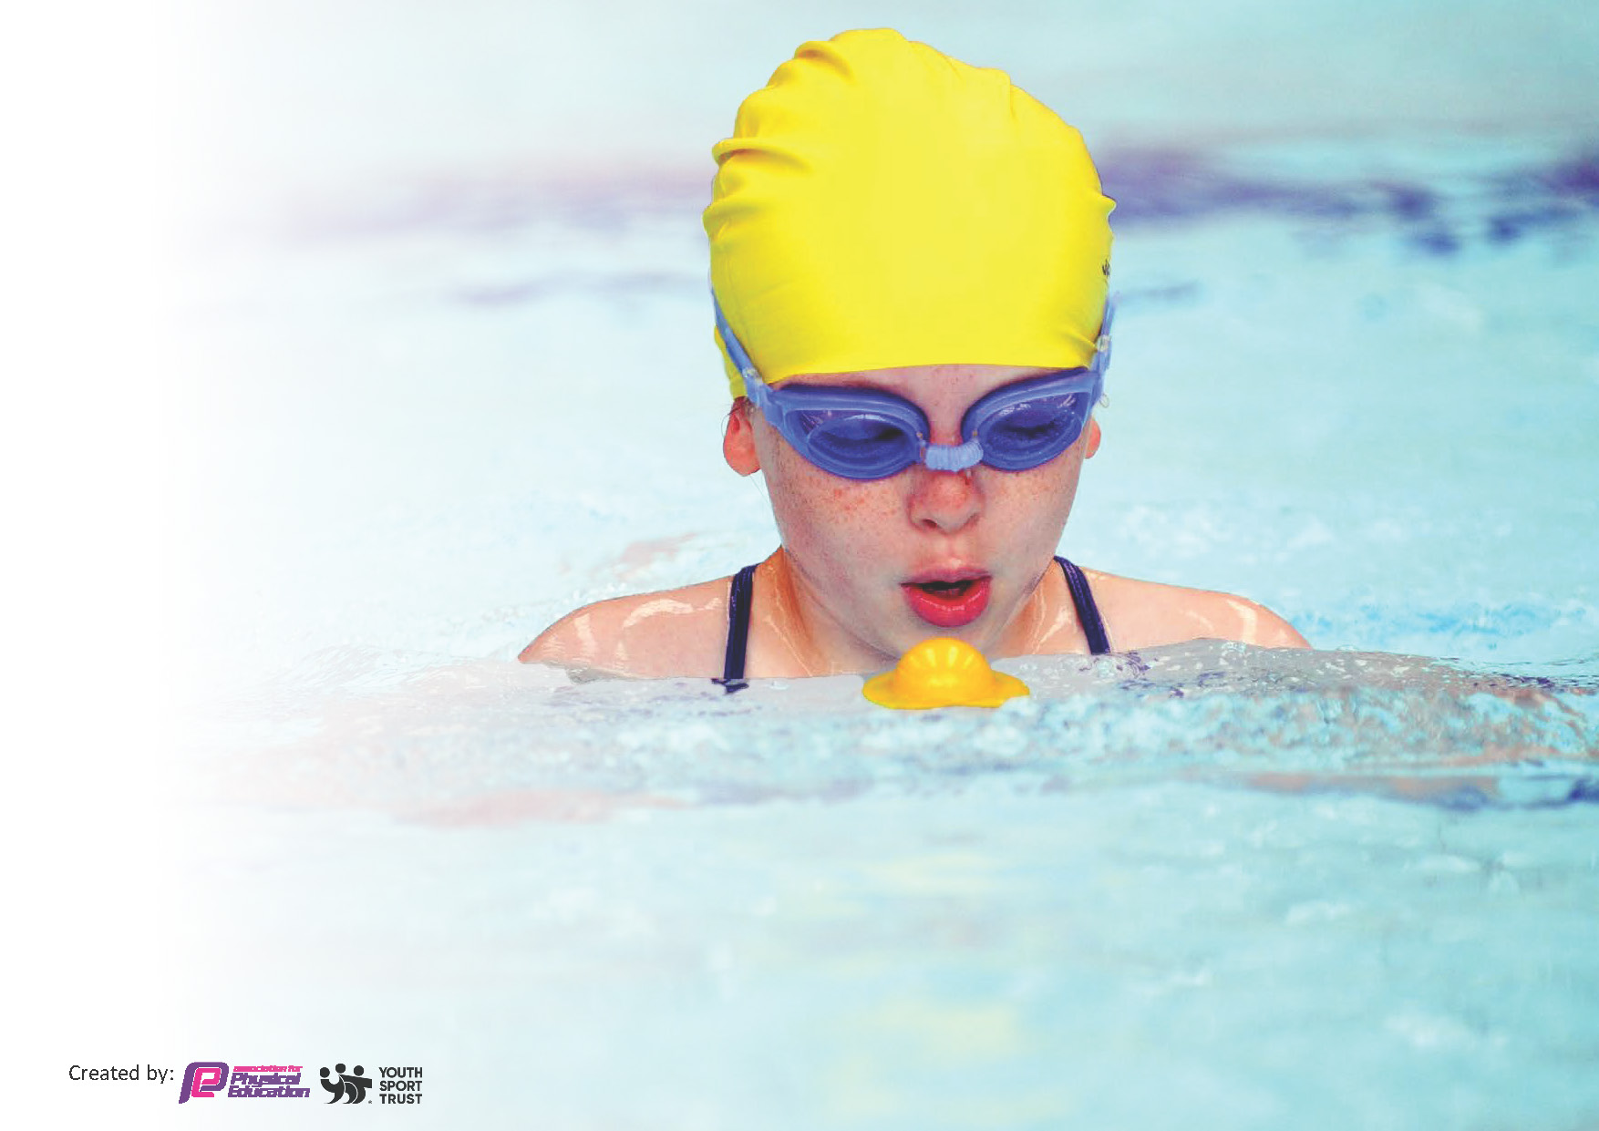
This template can be used for multiple purposes:
by:
- It enables schools to effectively plan their use of the Primary PE and sport premium
- It helps schools to meet the requirements (as set out in guidance) to publish information on their Primary PE and sport premium
- It will be an effective document to support Ofsted inspections enabling schools to evidence progress in Physical Education (PE) and evidence swimming attainment, which forms part of the PE National Curriculum. We would recommend schools consider
the Intent, Implementation and Impact of any spend, as examined within the Education Inspection Framework.

It is important that your grant is used effectively and based on school need.

Schools must use the funding to make additional and sustainable
improvements to the quality of the PE, School Sport and Physical Activity (PESSPA)
they offer. This means that you should use the Primary PE and sport premium to:

- Build capacity and capability within the school to ensure that improvements made now will benefit pupils joining the school in future years
- Develop or add to the PESSPA activities that your school already offers.

The Primary PE and sport premium should not be used to fund capital spend projects; the school’s core budget should fund these. Further detail on capital expenditure can be found in the updated Primary PE and sport premium guidance.

The Primary PE and sport premium guidance, outlines 5 key priorities that funding should be used towards. It is not

necessary that spending has to meet all the key priorities, you should select the priorities that you aim to use any funding towards.

Although completing this template is not a requirement for schools, schools are required to publish details of how they spend this funding. Schools must also outline what the impact this funding has had on pupils’ PE and sport participation and attainment and how any spending will be sustainable in the future. All funding must be spent by 31st July 2024.

The Department for Education has worked closely with the Association for Physical Education (afPE) and the Youth Sport Trust (YST) to develop this template and encourages schools to use it. This template is an effective way of meeting the reporting requirements of the Primary PE and sport premium.
Review of last year’s spend and key achievements (2022/2023)

We recommend you start by reflecting on the impact of current provision and reviewing your previous spend.

Activity / Action |  | Impact | Comments
Key indicator 1: The engagement of all pupils in regular physical activity
Improved knowledge and skills for all pupils.  Additional provision before, during and after school for targeted pupils  Increased participation in physical activity for all pupils  Target less active and disadvantaged pupils for intervention, including increased participation in inter school sports |  | Our analysis shows that in KS 2, 72% of pupils get at least 60 minutes exercise a day – this figure is likely to be greater, as for a few children, the amount of exercise is difficult to determine  PE was not a focus for formal monitoring during the academic year. Informal review shows a range of opportunities are planned and delivered, and children are positively engaged in PE within school  At least 72% of children in KS 2 are physically active  At least 52% of children in KS 2 took part in an after school sports club  72% of KS 2 children attended a residential during the 2022/23 academic year  77% of children took part in an inter school sports competition  Boccia was used to provide less active and able pupils with an opportunity to take part in competitive physical activity | Ensure INSET session is used to support teachers and PE coach in assessment and planning for PE  Review curriculum planning resources used currently, and these available. Consider use of additional / enhanced schemes for implementation in 2024/25
Key indicator 2: The profile of PESSPA being raised across the school as a tool for whole school improvement
Ensure all pupils have access to a variety of outdoor activities, including outdoor adventurous activities by attending a residential or taking part in similar activities at school  House Flag system used to raise profile of sport  Competitions organised linked to House system |  | All KS 2 children had an opportunity to participate in OAA during the academic year as part of a residential visit or through an alternative activity in school  Alternate opportunities were provided , outside of residential, but these were less impactful  The house system had been used effectively for competitions internally – these need to be expanded. 77% of KS 2 children took part in these activities | In 2023, ensure enhanced OAA provision is available for pupils who do not attend residential visits
Key indicator 3: Increased confidence, knowledge and skills of all staff in teaching PE and sport £1000
Staff supported in their planning and delivery of PE through an experienced coach  Ensure a variety of PE resources available to support teacher expertise | Staff met informally, throughout the year, to discuss planning and assessment in PE.  The intention is that these sessions will be developed, utilising INSET session times, during the next academic year. |  | Build in time for PE lead to meet with subject coordinators to support with planning and assessment  Consider using INSET time for this
Key indicator 4: Broader experience of a range of sports and activities offered to all pupils £3000
Provide a breadth of experience in class PE provision to enable pupils to experience a range of sports.  Take part in a range of inter and intra sports competitions  Ensure a wide variety of after school provision available  Ensure as many pupils as possible experience additional sports, team building, outdoor activities through attending residential | Curriculum planning map has been reviewed with additional activities, and a breadth of provision catered for.  Additional inter school competitions arranged – football and cricket took place and were popular  52% of KS 2 children took part in at least one of these activities  100% of KS 1 children who took part in a Forest school session in 2022-23  72% of children in KS 2 who took part in a residential visit which involved outdoor / adventurous activities during 2022 /23. |  | Ensure sports coach and teachers are provided with time to receive appropriate support and guidance as necessary.  Continue with inter school sports / flag system to enable as many children to participate in sports activities as possible  In May 2024, consider applying for primary games award
Key indicator 5: Increased participation in competitive sport

Ensure broad range of competitions entered  House system used as teams for inter house sports competitions – ensure inter house competitions run at regular intervals  Ensure involving girls in physical education and sports competitions is prioritised | School entered a range of competitive and non- competitive sports events organised through the family of schools.  These included orienteering, basketball, football, multi sports and gymnastics  School arranged regular sports coaching sessions specifically for girls. These included football sessions and multi sports sessions arranged by the linked comprehensive school |  | Excellent transport provision enables school to take part in these opportunities  These should continue ion 2023-24.  School should target additional focussed provision, for girls and children less engaged or able , ion physical activity

Key priorities and Planning
This planning template will allow schools to accurately plan their spending.

Action – what are you planning to do | Who does this action impact? | Key indicator to meet | Impacts and how sustainability will be achieved? | Cost linked to the action
To coach sports leaders who will support younger pupils with physical activity at break times | Develop children’s leadership skills. Helps ensure children are active at break times | Key Indicator 1  Engagement of all pupils in regular physical activity | More pupils will meet their daily physical activity goal, more pupils encouraged to take part in PE | For two terms, employ an additional midday supervisor –  Cost £100 a week  25 weeks £2500

To extend wider sports provision ensuring there are opportunities before school, during break and after school to engage more children in physical activity | Ensure provision is offered at wider range of times and dates – offer provision at lunch time and in the mornings free of charge | Key Indicator 1  Engagement of all pupils in regular physical activity  Key Indicator 2  The profile of PESSPA being raised across school  Key Indicator 4  Broader experience of a range of sports and activities offered to all pupils | More pupils will meet their daily physical activity goal, more pupils encouraged to take part in PE | £1500 – contribution of cost of sports coaches and other staff

To work towards the Bronze award for SGM | Will impact children by enabling a comprehensive review of current schools sports provision | Key Indicator 3  Increased confidence, knowledge and skills of all staff in teaching PE and sport | Provision for all pupils will be enhanced | £750 – cost of release time for staff

Target less active and disadvantaged pupils for increased participation in extra curricular sports activities | This will impact children less engaged, for whatever reason, in sport and physical activity | Key Indicator 1  Engagement of all pupils in regular physical activity  Key Indicator 5  Increased participation in competitive sport | Less active pupils more engaged in sports activities | £600  (further subsidy is made available for children who attend residential visits)

Review, together with teachers and PE Coach, available planning resources for PE that align with provision currently available | Schools is considering purchasing a scheme for PE provision – beginning Sept 2024. | Key Indicator 3  Increased confidence, knowledge and skills of all staff in teaching PE and sport | INSET and staff discussion time | £500

Use PE coach to support teaching and learning in PE across school. Coach will: team teach with each teacher to support teacher development, support class teachers with planning and assessment on a regular basis  Coach will provide informal support to teaching staff throughout the year | Teachers are more confident and skilled in teaching PE  Teachers more accurately use formative and summative assessment to inform teaching | Key Indicator 3  Increased confidence, knowledge and skills of all staff in teaching PE and sport  Key Indicator 4  Broader experience of a range of sports and activities offered to all pupils | More effective provision in class through better planning and assessment in PE. | £30 an hour – estimated 42 lessons = £1260  £150 for 8 days support for staff  £1200  £1000 for informal support  £1000

Contribute towards the cost of 2 establishment mini busses that will enable children to take part in sports activities and residential visits | This will enable more children to take part in competitive sports, both in school time, and after school. This also enables more children to take part in residential visits | Key Indicator 1  Engagement of all pupils in regular physical activity  Key Indicator 5  Increased participation in competitive sport | More children will take part in physical activity. More children will take part in residential visits. More children will be active. | £3000

Provide Forest school sessions for pupils in F2 and KS1 | Forest schools is a brilliant way to help children become physically active and spend more time outdoors | Key Indicator 1  Engagement of all pupils in regular physical activity | Younger children become fitter. They are engaged more in outdoor physical activity. Children become more physically and mentally resilient | £3000

Purchase of PE scheme | The school are considering purchasing a PE scheme for the beginning of the 2024/25 academic year. | Key Indicator 3  Increased confidence, knowledge and skills of all staff in teaching PE and sport | Improved planning for PE will enhance provision across school | Costs of scheme vary – likely to be a higher initial cost.  Estimated £1000

Investment in OPAL scheme | School is considering purchasing the OPAL scheme to enhance provision for pupils at playtimes. | Key Indicator 1  Engagement of all pupils in regular physical activity |  | Cost of this scheme are significant - £5000. However, the benefits will be ongoing. Will decide on the timing of implementation in the summer term

Purchase of additional resources | Additional equipment purchased during the year for PE and playtimes | Key Indicator 1,3,4,5 |  | £500

Totals | Funding allocated  £18,070  Planned expenditure  £21,810  Above expenditure and costings to be reviewed early in the summer term, following budget review.

Swimming Data
Meeting National Curriculum requirements for swimming and water safety.
Priority should always be given to ensuring that pupils can perform safe self-rescue even if they do not fully meet the first two requirements of the National Curriculum programme of study

Question | Stats: | Further context  Relative to local challenges
What percentage of your current Year 6 cohort can swim competently, confidently and proficiently over a distance of at least 25 metres? | 92% | Current cohort are very strong swimmers, with excellent parental support for swimming outside of school time. Children benefitted from excellent provision in years 3 and 4.  Maybe possibility for further sessions in the summer of 2024
What percentage of your current Year 6 cohort can use a range of strokes effectively [for example, front crawl, backstroke, and breaststroke]? | 73% | Current cohort are very strong swimmers, with excellent parental support for swimming outside of school time. Children benefitted from excellent provision in years 3 and 4.  Maybe possibility for further sessions in the summer of 2024

What percentage of your current Year 6 cohort are able to perform safe self-rescue in different water-based situations? | 81% | Current cohort are very strong swimmers, with excellent parental support for swimming outside of school time. Children benefitted from excellent provision in years 3 and 4.  Maybe possibility for further sessions in the summer of 2024
If your schools swimming data is below national expectation, you can choose to use the Primary PE and sport premium to provide additional top-up sessions for those pupils that did not meet National Curriculum  requirements after the completion of core lessons. Have you done this? | No | na
Have you provided CPD to improve the knowledge and confidence of staff to be able to teach swimming and water safety? | No | na

Signed off by:

Head Teacher: | Mark North
Subject Leader or the individual responsible for the Primary PE and sport premium: | Mark North and Nico Devivo
Governor: | April Wood
Date: | Update January 2024

